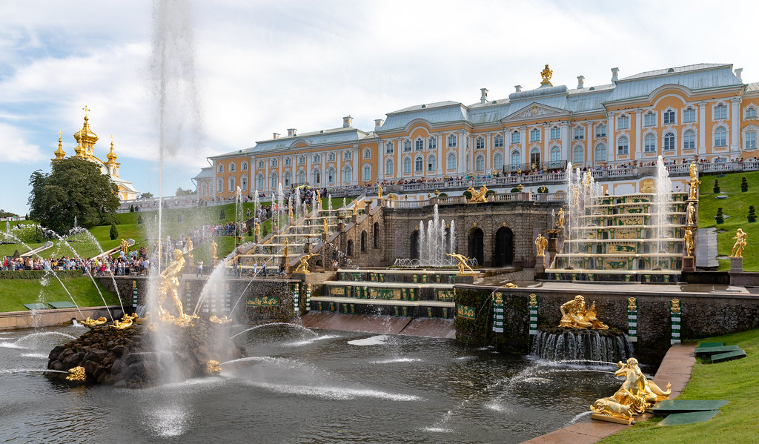

# Peterhof Palace

The **Peterhof Palace** (Russian: Петерго́ф, [romanized](https://en.wikipedia.org/wiki/Romanization_of_Russian): *Petergóf*, IPA: [[pʲɪtʲɪrˈɡof]](https://en.wikipedia.org/wiki/Help:IPA/Russian); an emulation of [German](https://en.wikipedia.org/wiki/German_language) "Peterhof", meaning "Peter's Court") is a series of palaces and gardens located in [Petergof](https://en.wikipedia.org/wiki/Petergof" \o "Petergof), [Saint Petersburg](https://en.wikipedia.org/wiki/Saint_Petersburg), [Russia](https://en.wikipedia.org/wiki/Russia), commissioned by [Peter the Great](https://en.wikipedia.org/wiki/Peter_the_Great) as a direct response to the [Palace of Versailles](https://en.wikipedia.org/wiki/Palace_of_Versailles) by [Louis XIV of France](https://en.wikipedia.org/wiki/Louis_XIV_of_France).[[3]](https://en.wikipedia.org/wiki/Peterhof_Palace#cite_note-:0-3) Originally intending it in 1709 for country habitation, Peter the Great sought to expand the property as a result of his visit to the French [royal court](https://en.wikipedia.org/wiki/Royal_court) in 1717,[]](https://en.wikipedia.org/wiki/Peterhof_Palace#cite_note-:0-3) inspiring the nickname of "The Russian Versailles". The architect between 1714 and 1728 was [Domenico Trezzini](https://en.wikipedia.org/wiki/Domenico_Trezzini), and the style he employed became the foundation for the [Petrine Baroque](https://en.wikipedia.org/wiki/Petrine_Baroque) style favored throughout Saint Petersburg. Also in 1714, [Jean-Baptiste Alexandre Le Blond](https://en.wikipedia.org/wiki/Jean-Baptiste_Alexandre_Le_Blond), likely chosen due to his previous collaborations with Versailles landscaper [André Le Nôtre](https://en.wikipedia.org/wiki/Andr%C3%A9_Le_N%C3%B4tre), designed the gardens. [Francesco Bartolomeo Rastrelli](https://en.wikipedia.org/wiki/Francesco_Bartolomeo_Rastrelli) completed an expansion from 1747 to 1756 for [Elizabeth of Russia](https://en.wikipedia.org/wiki/Elizabeth_of_Russia). The [palace-ensemble along with the city center](https://en.wikipedia.org/wiki/Historic_Centre_of_Saint_Petersburg_and_Related_Groups_of_Monuments) is recognized as a [UNESCO World Heritage Site](https://en.wikipedia.org/wiki/World_Heritage_Site).

## **Construction**

The end of the [Great Northern War](https://en.wikipedia.org/wiki/Great_Northern_War) resulted in the [Treaty of Nystad](https://en.wikipedia.org/wiki/Treaty_of_Nystad) in 1721, ceding much of the [Swedish Empire's](https://en.wikipedia.org/wiki/Swedish_Empire) claim to the [Baltic Sea](https://en.wikipedia.org/wiki/Baltic_Sea) to the rising [Tsardom of Russia](https://en.wikipedia.org/wiki/Tsardom_of_Russia" \o "Tsardom of Russia). Peter the Great already began construction of his new capital St Petersburg in 1703 after successfully capturing Swedish provinces on the eastern coast.[[7]](https://en.wikipedia.org/wiki/Peterhof_Palace#cite_note-7) This strategic location allowed Russian access to the Baltic Sea through the [Neva River](https://en.wikipedia.org/wiki/Neva_River) that flowed to the [Gulf of Finland](https://en.wikipedia.org/wiki/Gulf_of_Finland). The island of [Kotlin](https://en.wikipedia.org/wiki/Kotlin_Island" \o "Kotlin Island) and its fortress [Kronstadt](https://en.wikipedia.org/wiki/Kronstadt" \o "Kronstadt) west of St Petersburg provided a gateway and commercial harbor access owing to the shallowness of water closer to the city.

Throughout the early 18th century, Peter the Great built and expanded the Peterhof Palace complex as a part of his goal to modernize and westernize Russia.